SmartDocs User Guide

Version 1.0 – October 2018

Table of Contents

Logging On 2

Navigation Bar/Main Menu 2

Navigation Bar Options: 2

Main Menu Options: 2

MyPPAs Screen 3

Create/Edit a PPA 4

Employee Information Page 4

Position/Rating Information Page 5

Comments/Recommendations Page: 6

Save Page: 7

# Logging On

Visit the application link here: [SmartDocs](http://pgpdsod.co.pg.md.us:8080). If you haven’t visited the site recently, you will likely be prompted to enter your County logon credentials. This is the same username/password that you use to log on to County computers. The intranet (not internet) webserver on which SmartDocs is hosted is configured to ensure that only authorized people can access the app.

### Navigation Bar/Main Menu

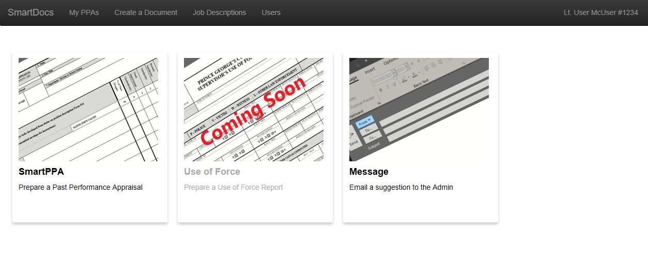Once you log in, you should see the Main Menu screen:

Figure : Main Menu

### Navigation Bar Options:

**\*NOTE**: If you see a message that says:

“*You have not been given access to this application*”

you need to contact the SmartDocs admin at [jcsmith1@co.pg.md.us](mailto:jcsmith1@co.pg.md.us) so that an account can be created for you.

* **SmartDocs:**  clicking here will take you to a page with basic information about the application.
* **MyPPAs:**  clicking here will show you a list of SmartPPAs that you have already created. From this list, you can re-download, edit, or delete PPAs that you have authored. (See MyPPAs Screen for details.)
* **Create a Document:** clicking this link will take you to the page where you can begin a new PPA. (See Create/Edit a PPA Screen for details)
* **Job Descriptions:** this link will allow you to view a list of all of the Job Descriptions that are currently enabled in the SmartPPA. From this list, you can see a detailed breakdown of the Job Description Categories. (See Job Descriptions Screen for details)
* **Your Name:** clicking on your name will allow you to change how your name appears in SmartDocs and on the documents you create. This will allow you to format your name in your preferred style and update your rank if you need to. (I tried to make sure everyone’s rank/name/id is correct, but it isn’t easy with 1800 officers to keep updated.)

### Main Menu Options:

* **SmartPPA:** click this link to create a new SmartPPA. (See Create/Edit a PPA Screen for details)
* **Use of Force:** Not enabled in this version.
* **Message:** click here to send an Email to the Admin. I welcome any feedback or suggestions you have.

# MyPPAs Screen

When you click this link, it will bring you to a page that will display all of the PPAs that you have authored. If you are accessing the application for the first time, the list will be empty. Once you complete a PPA, it will be displayed on the list screen:

Figure : MyPPAs Screen

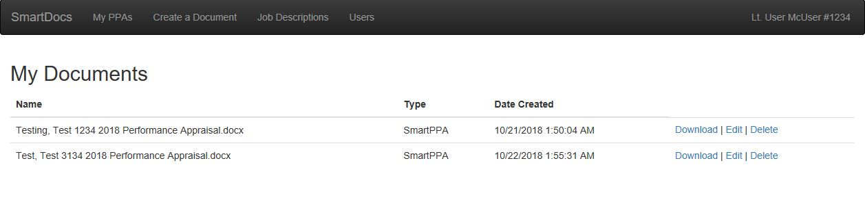

Each row in this list represents a separate PPA document that you have created. You are the only person who has access to the documents you author, and you only have access to your own documents. The following information is displayed for each document:

* **Name:** This is the name of the Word Document file. This name is automatically written by the application at the time the document is first created. The file name has this format:
  + The Last name, First Name, and ID# of the employee who is the subject of the PPA
  + The Year of the appraisal.

So in Figure 2 above, the first document is the 2018 Performance Appraisal for an employee named Test Testing #1234. Although the name of the file on the server is set by the application, you are free to rename any of files that you download.

* **Type:** The type of the document. As of SmartDocs 1.0, a SmartPPA is the only document type.
* **Date Created:** the date that you created the SmartPPA
* **Download:** this link will download a new copy of the SmartPPA.
* **Edit:** This will take you to the Editing Screen, where you can make changes or corrections to an existing PPA. (See Create/Edit a PPA Screen for details)
* **Delete:** This will allow you to delete a PPA. (**CAUTION:** Deleting a PPA is permanent and irreversible. Do not delete a document unless you are certain that you do not need it.)

# Create/Edit a PPA

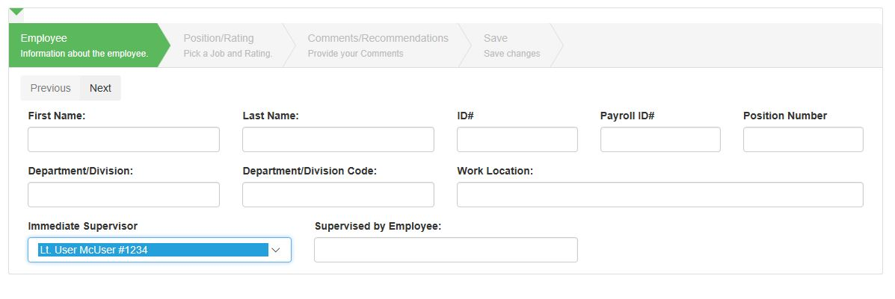If you choose “Create a Document” from the Navigation Bar, “SmartPPA” from the Main Menu Screen, or “Edit” for a PPA on the MyPPAs screen, you will be directed to the PPA data entry form:

Figure : PPA Data Entry Form – Employee Info

### Employee Information Page:

This sequential form is designed to help you gather all of the information needed for an accurate, complete PPA. The first page displayed collects information about the employee:

* **First Name:** enter the first name of the employee that is the subject of the appraisal.
* **Last Name:** enter the employee’s last name.
* **ID Number:** enter the employee’s Department ID Number. (Do not include a ‘#”)
* **Payroll ID Number:** enter the employee’s ETS Payroll ID. This field replaces the Social Security Number required on previous versions of the PPA form.
* **Position Number:** enter the employee’s position number.
* **Department/Division:** enter the Division to which the employee is assigned. Normally, you should enter “Police,” followed by the employee’s Bureau and Division, but other formats are not uncommon. For example:
  + **Police/BOP/District I**
  + **Police/SOD/Aviation**
  + **Police/BOI/RID-N**
* **Department/Division Code:** this is the (normally 4-digit) code for the employee’s Department/Division. Contact Police Personnel if you do not know the proper code for your Department/Division.
* **Work Location:** enter the street address for the employee’s primary work location.
* **Immediate Supervisor:** In most cases, this will be your name. The server will automatically populate this field with your name, but it will allow you to change it to another user. (**CAUTION –** If you change this field to another user and save the SmartPPA, you will be permitted to download a copy of the PPA, but you will not be able to edit or re-download the SmartPPA after it is created. This field will assign the SmartPPA to whichever user’s name is in this field. Don’t change the default value unless you are certain that you need to.
* **Supervised by Employee:** if the employee you are evaluating is a supervisor for a component (a patrol sergeant, for example), put the name of the component in this field. If the employee is not a supervisor, you may skip this field (the application will set the field to “N/A” if there is no name provided.

Once you have completed the fields on this page, click the “Next” button (above “First Name”) to proceed to the next page.

### Position/Rating Information Page:

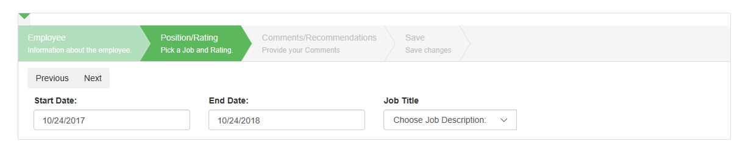If this is a new PPA, the next page will only show 3 fields:

Figure : Position/Rating Info - Initial

* **Start/End Date:** these fields correspond to the beginning and ending date of the Appraisal Period, which should be the anniversary of the employee’s date of hire. For convenience, these fields default to today’s date, but unless you are doing the employee’s PPA on their anniversary date, you will need to change these fields.
* **Job Title:** This is a drop-down list of all available Job Descriptions that are available in SmartDocs. Select the employee’s Job Description to proceed. (**NOTE:** if you don’t see the job description you need in the list, then contact the admin at [jcsmith1@co.pg.md.us](mailto:jcsmith1@co.pg.md.us) to have it added)

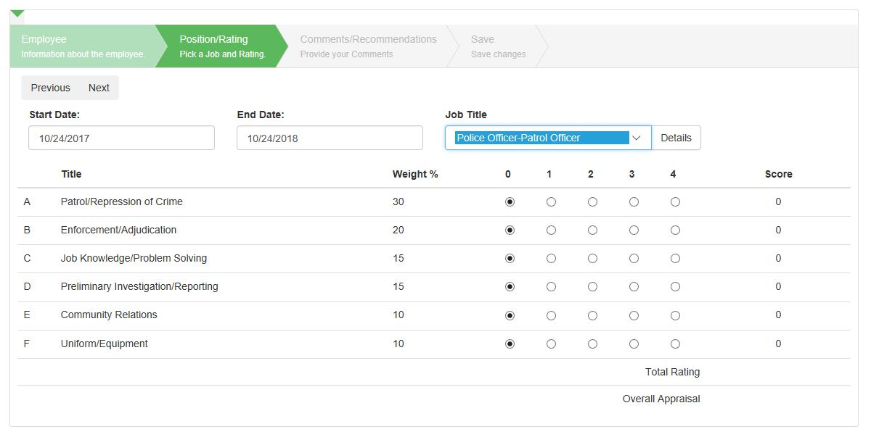Once you select a job description, a new form will appear:

Figure : Category Rating Form

This new form displays the categories for the selected Job Description and allows you to select a rating for each. The form will automatically calculate the employee’s overall rating and appraisal as you change the ratings. Additionally, a “Details” button will appear next to the Job Description drop-down box. If you click the “Details” button, the server will display the full text of the selected Job Description for your review. (**NOTE:** it will attempt to open this in a new tab, which may be blocked by “pop-up” blockers in certain browsers. If you click “Details” and nothing happens. Check for a “pop-up blocked” warning. If there is a warning, you can click it to allow “pop-ups” from SmartDocs only. The Job Description Details open in a new tab to allow you to refer to them as you rate an employee and make recommendations in the next section.)

Once you have selected a Job Description and assigned ratings for each category, click “Next” to proceed to the next section.

### Comments/Recommendations Page:

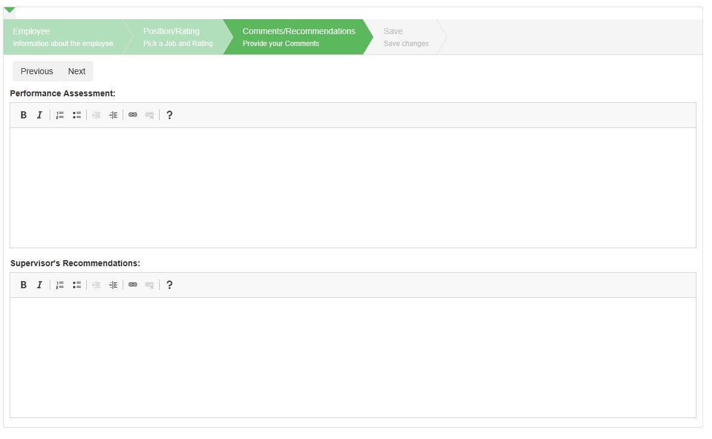The Comments/Recommendations Section will appear next:

Figure : Comments/Recommendations Page

This page has two sections:

* **Performance Assessment:** provide your detailed assessment of the employee’s performance during the rating period.
* **Supervisor’s Recommendations:** provide your recommendations.

Once you are finished, click “Next.”

### Save Page:

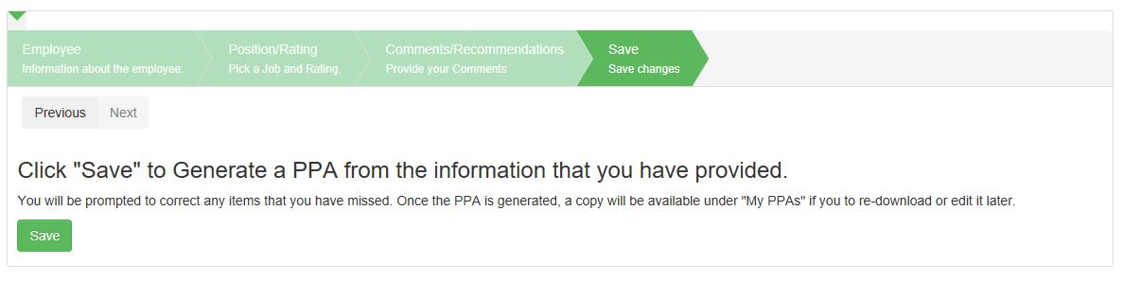The final page of the form will allow you to save the PPA:

Figure : Save page

If you are satisfied with the information you have provided, you can click the “Save” button, and the application will send a copy of the resulting SmartPPA to your browser: